public transportation efficiency

Data Collection and Preparation:

Gather relevant data sources, including information on routes, schedules, ridership, and operational costs.
Ensure the data is clean and well-structured, possibly using tools like IBM DataStage or other ETL processes.
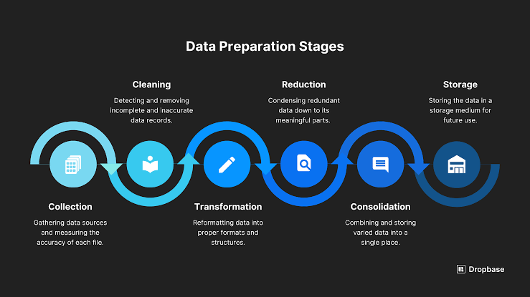

Data Modeling:

Create a data model within IBM Cognos Framework Manager to define the relationships between data tables and prepare the data for analysis.

Report Creation:

Build reports in Cognos that display key performance indicators (KPIs) related to transportation efficiency. These may include on-time performance, ridership trends, and cost analysis.
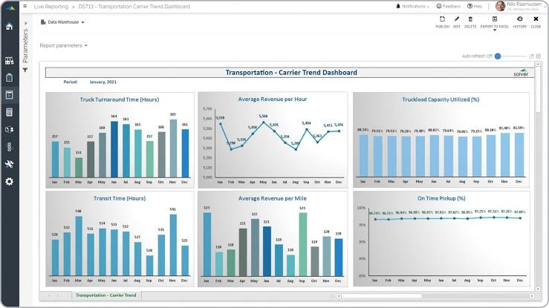

Dashboard Design:

Create interactive dashboards to provide a holistic view of transportation efficiency. Include visualizations like charts, graphs, and maps to represent the data effectively.
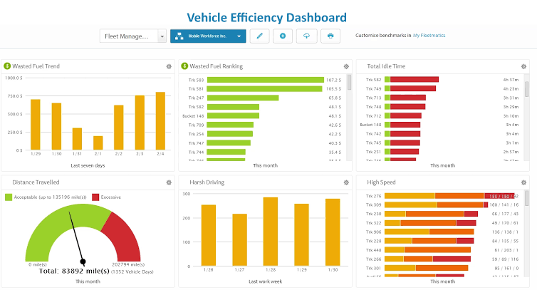

Performance Metrics:

Define and calculate performance metrics such as average wait times, route utilization, and cost per passenger.

Drill-Down Capability:

Enable drill-down functionality in your dashboards to allow users to explore data at different levels of detail.
Real-Time Data Integration (optional):

If applicable, set up real-time data integration to provide up-to-the-minute information about transportation services.
User Access and Security:

Implement user access controls and security measures to protect sensitive data.
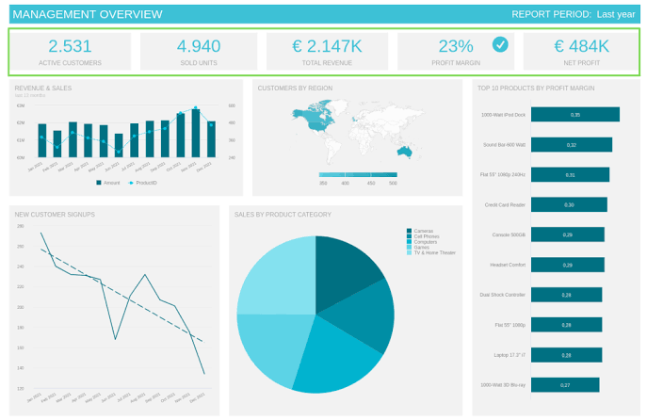

Testing:

Thoroughly test your reports and dashboards to ensure they display accurate and meaningful data.

Documentation:

Create documentation for end-users and administrators to understand and maintain the system.

Training:
Train users and administrators on how to use Cognos for transportation efficiency analysis

# Import necessary libraries and modules

import ibm_db
import ibm_db_dbi
import pandas as pd
from cognos_analytics import CognosAnalytics

# Connect to your data source (e.g., a database)

conn = ibm_db.connect("DATABASE=your_db;HOSTNAME=your_host;PORT=your_port;PROTOCOL=TCPIP;UID=your_user;PWD=your_password;", "", "")

# Use ibm_db_dbi to work with the connection

dbi_conn = ibm_db_dbi.Connection(conn)

# Define SQL queries to retrieve transportation data

query = "SELECT route, ridership, on_time_performance FROM transportation_data"
data = pd.read_sql(query, dbi_conn)

# Create a Cognos Analytics instance

cognos = CognosAnalytics("https://your-cognos-server")

# Log in to Cognos

cognos.login("your_username", "your_password")

# Define a data module and import the transportation data

data_module = cognos.create_data_module("Transportation Efficiency Analysis")
data_module.import_data(data, "TransportationData")

# Create data relationships in the data module (if needed)

# Define calculated measures and KPIs

# Create visualizations (reports and dashboards) using Cognos Dashboard Embedded

dashboard = cognos.create_dashboard("Transportation Efficiency Dashboard")
dashboard.add_report("Ridership Report", "Report1")
dashboard.add_report("On-Time Performance Report", "Report2")

# Add visualizations to the reports
dashboard.add_chart_to_report("Ridership Chart", "Ridership Report")

dashboard.add_chart_to_report("On-Time Performance Chart", "On-Time Performance Report")

# Configure report parameters (if needed)

# Publish the dashboard to make it available for users

dashboard.publish("Public Transportation Efficiency Analysis Dashboard")

# Log out from Cognos
cognos.logout()

# Close the database connection
ibm_db.close(conn)

